*Florida International University*

*School of Computing and Information Sciences*

Software Engineering Focus

Feature Document

User Story ID <NVOS-13 View and Browse Concepts >

**Name:** Bryan Bastida

**Team Member(s):** Bryan Bastida

Andrew Castillo

**Project:** Envo Scholar

**Product Owner(s)**: Mark Finlayson

**Mentor(s)**: Masoud Sadjadi

**Instructor**: Masoud Sadjadi

**User Story Name:** View and Browse Concepts

* Description: As a user, I want to view the ontology, so that I can see the concepts that I can find articles on.

Acceptance Criteria

* User has pressed on the Ontology tab from the homepage
* The ontology page opens and the user can now browse through the concepts

**Use Case**

* **Name**: View and Browse Concepts
* **Actor**: User and Web page
* **Preconditions**: User has accessed the Envo Scholar website
* **Postconditions**: Ontology shows view of concepts
* **Description** <Flow of events>:
  + User accesses the Envo Scholar website
  + User clicks on the Ontology tab
  + Page changes from homepage to ontology
  + Ontology shows the concepts and the user can navigate through it by exanding the

tree

**Use Case Diagram**

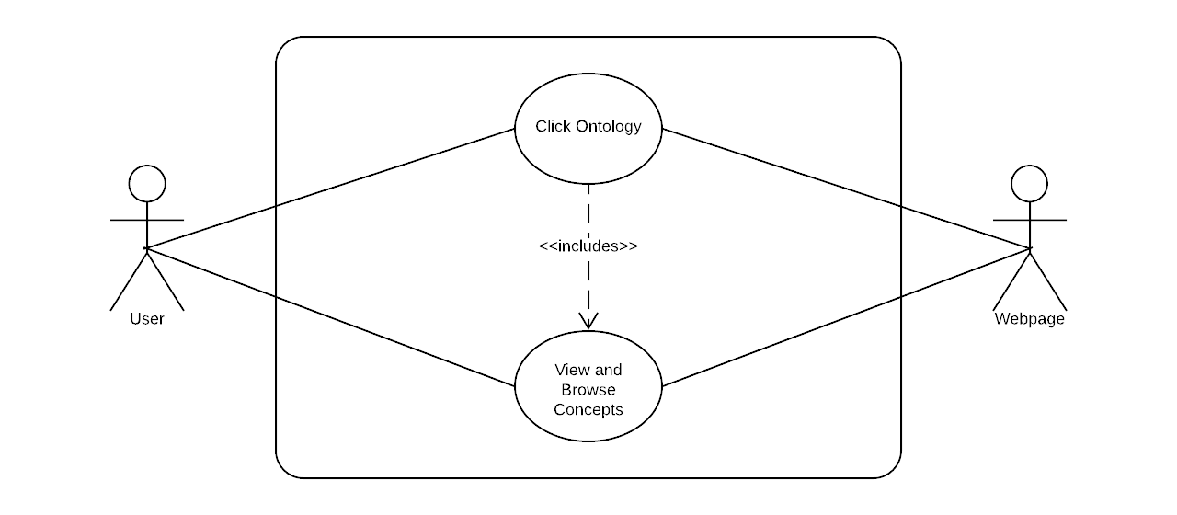

**Sequence Diagram**

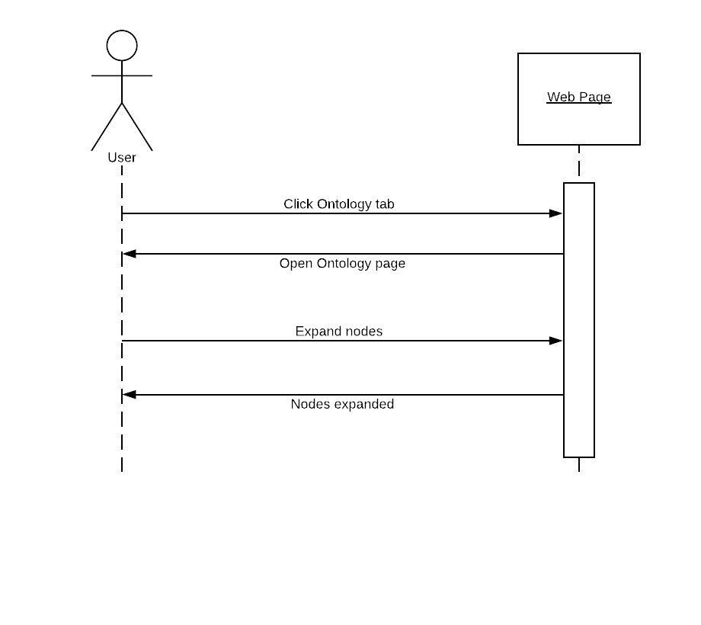

**Class Diagram**

­­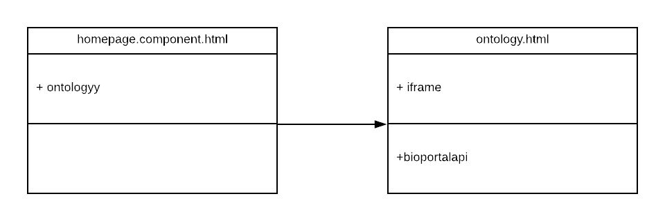

## ****Unit Test****

* Test case ID: NVOS-13-Browse-and-View-Concepts
* Description/Summary of Test: Ontology is displayed as a tree. User is able to expand nodes to traverse the tree.
* Pre-condition: User has opened the Ontology tab.
* Expected Results: : Ontology is displayed as a tree. User is able to expand nodes to traverse the tree.
* Actual Result: : Ontology is displayed as a tree. User is able to expand nodes to traverse the tree.
* Status (Fail/Pass): Pass

**Visual User Guide ()**

